**CONON BRIDGE COMMUNITY COUNCIL: 21 OCTOBER 2024**

**AGENDA ADDENDUM**

**ADDITIONAL ITEMS**

**18. COMMUNITY COUNCIL REVIEW 2024**

**Process for the Review**

The current Scheme of Establishment for Community Councils in Highland came into effect in 2019. The Local Government (Scotland) Act 1973 (section 53) states that every Local Authority shall from time to time review the Schemes made and approved under this Act and shall involve Community Councils and the wider public to make representations regarding the proposals.

To review the scheme under section 53 of the 1973 Act, the Council is required to undertake a two-stage process:

* **Stage one** – the formal decision to review and the outline proposals need to be passed by not less than two-thirds of Members voting at a special meeting of the Highland Council convened specifically for that purpose. Public notice is then given of the intention to review the Scheme along with details of the proposals, with Community Councils and the public invited to make representations regarding the proposals.
* **Stage 2 -** the Council will consider any representations made and may amend the Scheme in accordance with—
  + the notified proposals; or
  + those proposals as amended to take account of any such representations.

However, should the proposals be amended following representations received during stage 1, then further public notice shall be given and an opportunity provided for the public to comment on the amended proposals.

The final decision to amend the Scheme needs to be passed by not less than two-thirds of Members voting at a special meeting of the Highland Council convened for that purpose.

Before we proceed with stage 1 and publish any proposed amendments, we need to develop a proposed set of changes for the revised Scheme. We are keen to do this along with Community Councils to ensure that the proposals put forward are shaped by and reflective of what Community Councils identify as priorities.

Initial engagement with Community Councils is taking place from 19th September 2024 until 14th November 2024 using a survey to stimulate discussion on issues currently facing Community Councils. This will inform a series of proposals for consideration by a special meeting of the Council on 12th December 2024. Should these be agreed, a three-month public consultation would be held on the detailed proposals.

The initial survey can be accessed by clicking on the link below to enable sharing and discussion amongst your Community Council:

[**https://forms.office.com/e/Dw86g6ywDy**](https://forms.office.com/e/Dw86g6ywDy)

In addition to any response agreed by the Community Council, individual Community Councillors are also welcome to respond via the above link

**19. ARCHAEOLOGY:**

**CONON BRIDGE TIMELINE: ARCH HIGHLAND**

We're quite happy to talk about a Community Timelines course in Conon. Crossing the river must have been a real focal point in the past (and I love your CBCC logo!), and there is so much potential multi-period heritage in Conon to explore.

Our Community Timelines courses are usually three modules - first sharing memories of sites/buildings/finds, then research to find out more about them, often with a trip to the archives and museum, and walks to explore), then creating a display (usually a portable one, but it can be fixed if there is a venue).

This lasts several months, and generates a huge amount of information, some of which we forward to the Highland Historic Environment Record (HER), Highland Council's database of all known heritage. The sessions are always popular, and can lead to further projects.

Funding is usually from organisations like the National Lottery Heritage Fund, and costs tend to run around £8-10K for the full three modules. This would be something the Community Council would have to apply for, but we could help.

20. CHRISTMAS 2024

OAP LUNCHES

LIGHTS

21. WINDFARMS

FYRISH

The **Ceislein Onshore Wind Farm** is a proposed wind energy project by RWE, located to the east of the operational Novar 2 Wind Farm in the Highlands of Scotland. [The project is currently in the early stages of development, with a scoping report submitted to the Scottish Government’s Energy Consents Unit in August 20241](https://www.rwe.com/ceislein/)[2](https://www.energyconsents.scot/ApplicationDetails.aspx?cr=ECU00005174).

[The proposed wind farm could feature up to 20 turbines, each up to 250 meters tall, with a total generating capacity exceeding 50 megawatts (MW)2](https://www.energyconsents.scot/ApplicationDetails.aspx?cr=ECU00005174). [Public consultations have been held to gather community feedback and ensure local involvement in the planning process1](https://www.rwe.com/ceislein/)[3](https://www.northern-times.co.uk/news/consultation-events-planned-for-proposed-commercial-scale-w-357996/).

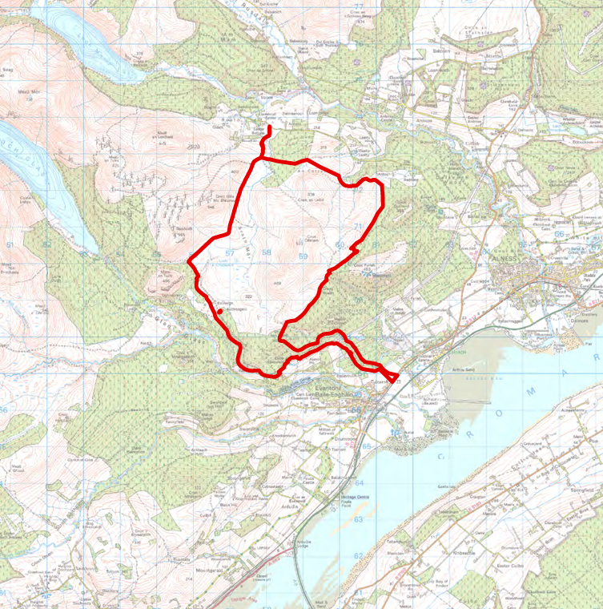

**STRUY**

Planning Authority Name THE HIGHLAND COUNCIL

Response Date 5th November 2024

Refrence; 24/04177/SCOP Major Application? Ward 12

Nature of Proposal

Scoping request for Ballach Wind Farm – Erection and Operation of a Wind Farm for a period of 35 years, comprising 36 turbines with a maximum blade tip height of 200m and 230m, along with a battery energy storage system (BESS) and ancillary infrastructure.

Site Land 6260M NE Of Erchless Forest Cottage, Struy, Beauly

